PHP Web Portal with DynamoDB on Ubuntu EC2
Virtual Private Cloud (VPC) :
VPC (Virtual Private Cloud) is a private, isolated network in AWS that allows you to securely run resources like EC2 instances.
You can control IP ranges, subnets, route tables, and gateways
Steps:
  - Go to VPC Dashboard → Create VPC.
  - Set IPv4 CIDR block (e.g., 10.0.0.0/16).
  - Create subnets (public for EC2, private if needed).
  - Create an Internet Gateway and attach it to your VPC.
Update route tables to allow internet access for public subnet
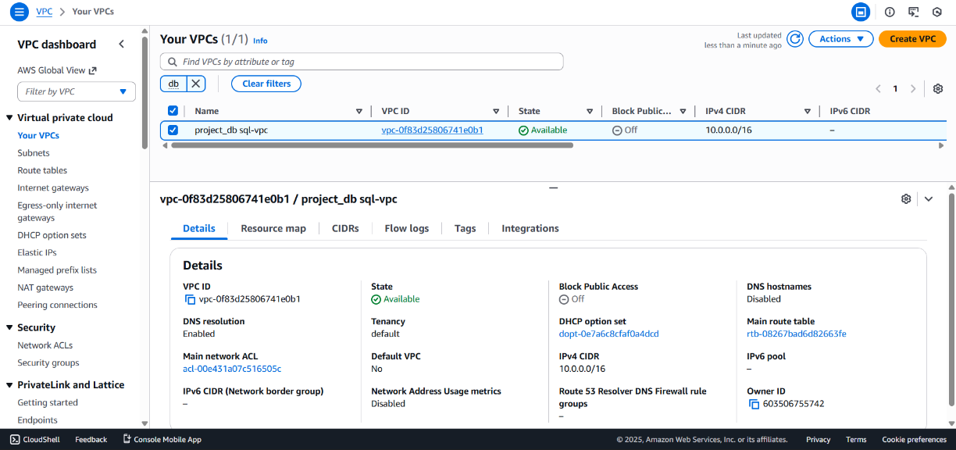
Launch an EC2 Instance
Go to EC2 Dashboard → Launch Instance.
Name: WebPortalServer
AMI: Ubuntu Server 22.04 LTS
Instance type: t2.micro
Key pair: Select or create a new key
Network settings:
VPC: web-portal-vpc
Subnet: web-public-subnet
Auto-assign public IP: Enable
Security Group:
Allow HTTP (80), SSH (22), HTTPS (443)
Attach IAM Role:
Role name: DynamoDBAccessRole
Policy: AmazonDynamoDBFullAccess
Click Launch Instance
Generate and download key pair (.pem) for SSH
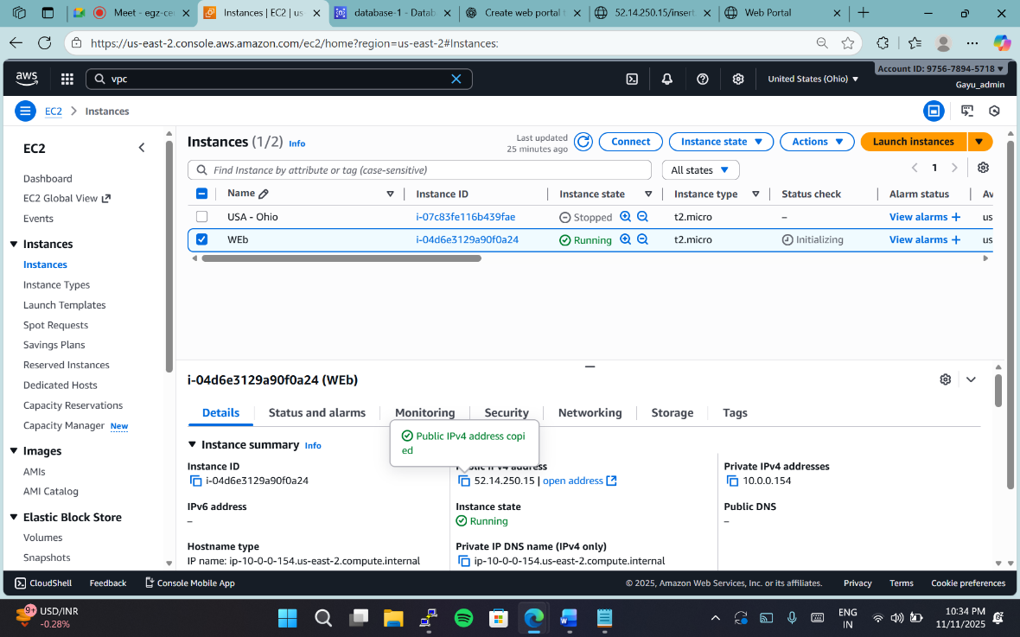
Connect and Configure EC2
SSH into instance:
ssh -i your-key.pem ubuntu@52.14.250.15
Install dependencies:
sudo apt update -y
sudo apt install -y apache2 php php-cli php-curl php-xml php-mbstring unzip curl git
Install Composer:
curl -sS https://getcomposer.org/installer | php
sudo mv composer.phar /usr/local/bin/composer
Set Up Web Application
cd /var/www/html
sudo rm -rf *
composer require aws/aws-sdk-php
sudo nano /var/www/html/index.php
DynamoDB Setup
Go to DynamoDB → Create Table
Name: PortalUsers
Partition key: email (String)
Leave default settings → Create Table
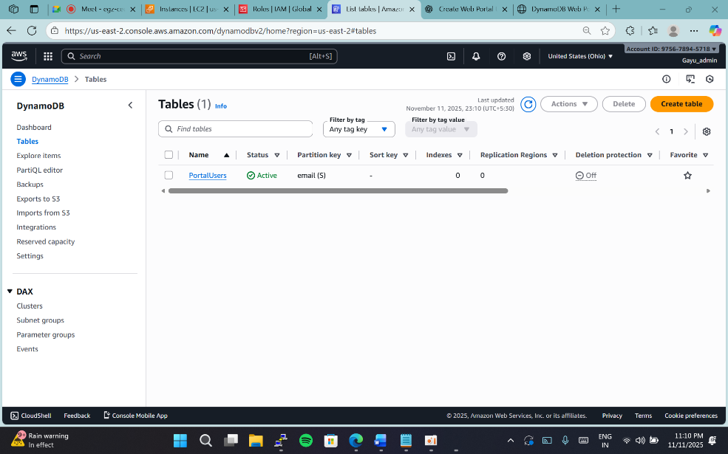
Create PHP Web Portal
<?php
require 'vendor/autoload.php';
use Aws\DynamoDb\DynamoDbClient;
$client = new DynamoDbClient([
'version' => 'latest',
'region' => 'us-east-1' // change if needed
]);
// If form submitted
if ($_SERVER['REQUEST_METHOD'] === 'POST') {
$name = $_POST['name'];
$age = $_POST['age'];
$email = $_POST['email'];
try {
$client->putItem([
'TableName' => 'PortalUsers',
'Item' => [
'email' => ['S' => $email],
'name' => ['S' => $name],
'age' => ['N' => $age],
'created_at' => ['S' => gmdate('c')]
]
]);
echo "<p style='color:green;'>Record saved successfully!</p>";
} catch (Exception $e) {
echo "<p style='color:red;'>Error: " . $e->getMessage() . "</p>";
}
}
?>
<!DOCTYPE html>
<html>
<head>
<title>DynamoDB Web Portal</title>
</head>
<body>
<h1>PHP Web Portal - AWS DynamoDB</h1>
<form method="POST">
<label>Name:</label><br>
<input type="text" name="name" required><br><br>
<label>Age:</label><br>
<input type="number" name="age"><br><br>
<label>Email:</label><br>
<input type="email" name="email" required><br><br>
<button type="submit">Submit</button>
</form>
</body>
</html>
IAM Permissions
Attach an IAM Role to your EC2 instance
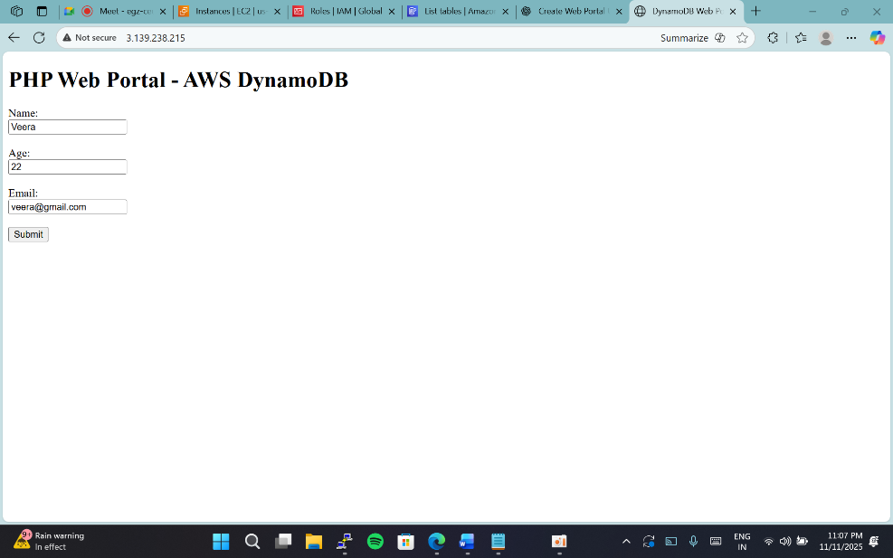

Test Application
Visit: http:// 52.14.250.15
Fill the form → submit → check data in DynamoDB
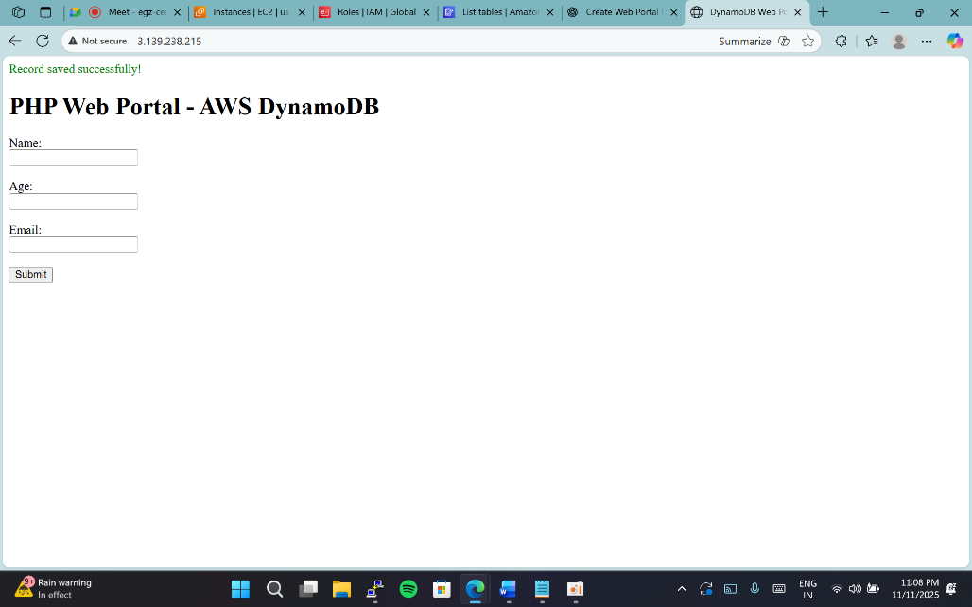
Verify in DynamoDB Console
Go to DynamoDB → Tables → PortalUsers → Explore Table Items
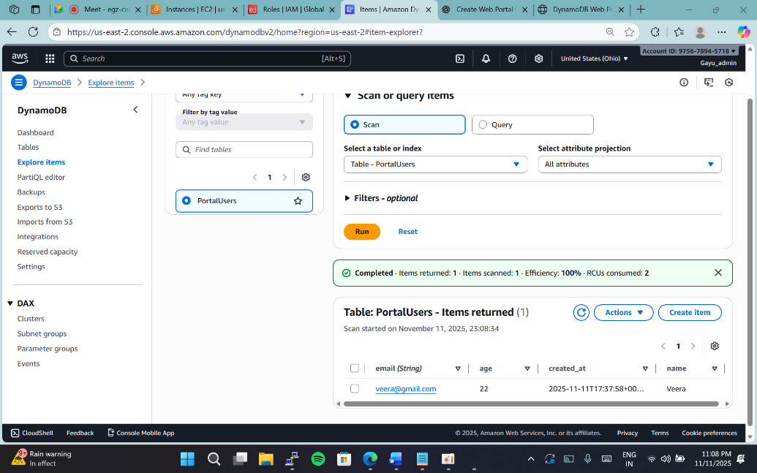
edit version
VPC Setup
EC2 Instance Setup
Install Dependencies
AWS SDK Installation
cd /var/www/html
composer require aws/aws-sdk-php
DynamoDB Setup
Go to AWS Console → DynamoDB → Create Table
Table name: EmployeeData
Partition key: Email (String)
Keep default settings → Create Table
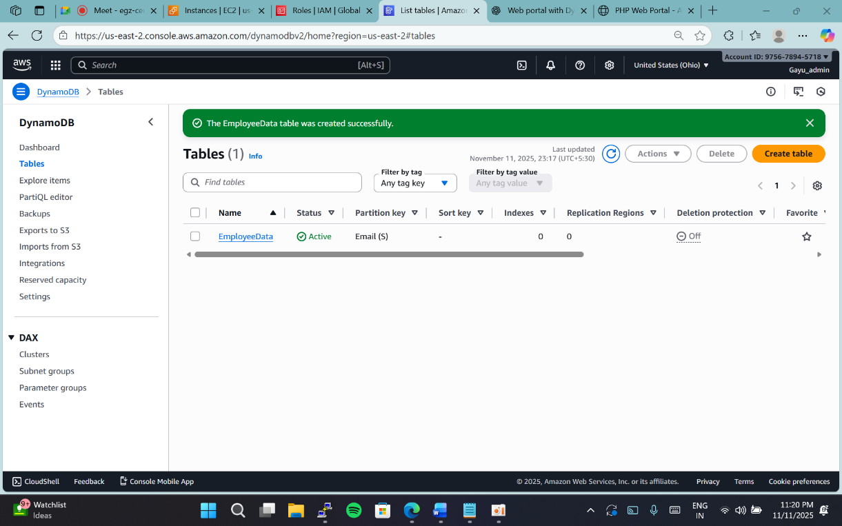
IAM Role & Policy
Go to IAM → Roles → Create Role
Trusted entity: EC2
Policy: AmazonDynamoDBFullAccess
Role name: DynamoDBAccessRole
Attach this role to your EC2 instance.
Application Code
index.php
<!DOCTYPE html>
<html>
<head><title>Employee Portal</title></head>
<body>
<h2>Employee Portal - AWS DynamoDB</h2>
<form action="submit.php" method="post">
Name: <input type="text" name="name" required><br><br>
Age: <input type="number" name="age" required><br><br>
Email: <input type="email" name="email" required><br><br>
Department:
<select name="department" required>
<option value="">--Select--</option>
<option value="HR">HR</option>
<option value="Ops1">Ops1</option>
<option value="Ops2">Ops2</option>
<option value="Audit">Audit</option>
</select><br><br>
<input type="submit" value="Submit">
</form>
</body>
</html>
Then submit.php
Verification
Visit: http:// 3.139.238.215/index.php
Fill form → Submit
Check DynamoDB → Table → Explore Table Items → Verify new record

